APQB AD/AS Equilibrium Questions
- The intersection of the AS curve and AD curve occurs at the economy’s equilibrium level of
- Real investment and interest rate
- Real disposable income and unemployment
- Real national output and the price level
- Government expenditures and taxes
- Imports and exports
- If the short run aggregate supply curve is upward sloping, which of the following will cause inflation?
- An increase in the long run aggregate supply
- An increase in the short run aggregate supply
- An increase in aggregate demand
- A decrease in the aggregate demand
- A decrease in aggregate demand and an increase in aggregate supply.
- 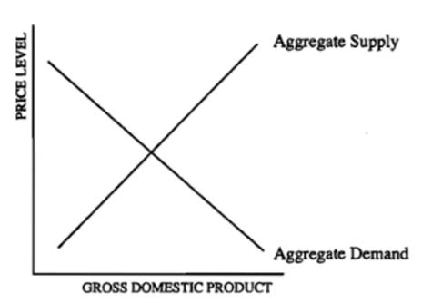According to the graph above, which of the following will necessarily result in a decrease in output?
- A rightward shift of the AD curve
- A leftward shift of the AD curve
- A rightward shift of the AS curve
- A leftward shift of the AS curve.
- I only
- III only
- I and III only
- II and III only
- II and IV only
- Which of the following will cause in increase in the real output in the short run?
- A decrease in productivity.
- A decrease in wages.
- A decrease in government expenditure.
- An increase in the interest rate.
- A decrease in firm borrowing for investment purposes.
- Which of the following will most likely cause an increase in both the price level and the real gross domestic product?
- Interest rate increases
- Exports increase
- Income taxes increase
- Crude oil prices decrease
- Inflationary expectations decrease
- Assume that an economy is currently in long run equilibrium and the short run aggregate supply curve is upwards sloping. An adverse supply shock, such as drought, will most likely cause which of the following to the economy in the short run.
- A decrease in the price level and a decrease in the nominal wage.
- A decrease in the price level and an increase in the nominal wage.
- An increase in the price level and an increase in the nominal wage.
- An increase in the price level and an increase in the real wage.
- An increase in the price level and a decrease in the real wage.
- A contractionary supply shock would most likely result in
- An increase in AD
- An increase in national income
- An increase in GDP
- A decrease in the general price level
- A decrease in employment
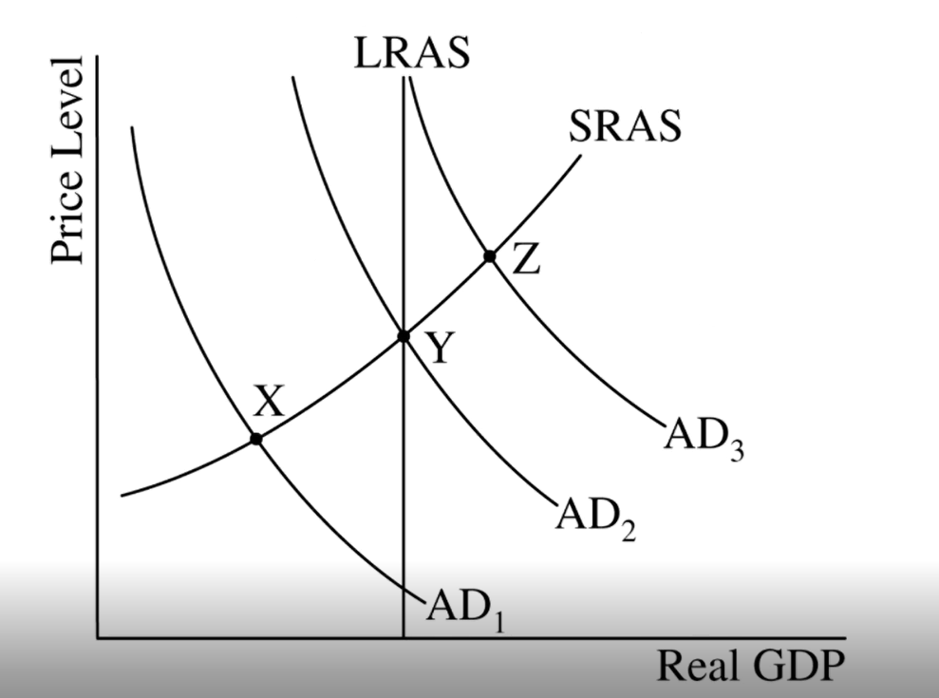
- Based on the graph, which of the following is most accurate?
- At Point Z, the economy has cyclical unemployment.
- At Point Z, the economy is in long run equilibrium but not in Short Run Equilibrium.
- At point Y, the natural rate of unemployment is zero.
- At point X, the economy is experiencing a recessionary gap.
- At point X, there is no frictional unemployment.
- During a period of stagflation, a nation is most likely experiencing
- High unemployment and low inflation
- Low unemployment and high inflation
- Low inflationary expectations
- A decrease in short run aggregate supply
- An increase in taxes and government spending
- An economy is currently operating at the full employment level of output. Which of the following would result in a recessionary gap in the short run?
- An increase in the costs of production
- An improvement in the productivity of labor
- A decrease in the interest rates
- A positive supply shock
- A decrease in income tax rates
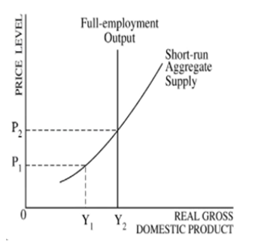
The economy above of Watsonia has an estimated NRU of 6 percent.
- If this is true and current rate of unemployment is 5.1 percent, in what range of real gross domestic product is the economy currently producing.
- Less than Y1
- At Y1
- At Y2
- Greater than Y1 and less than Y2
- Greater than Y2
- Assume an economy is at long run equilibrium. Which of the following would cause stagflation?
- A leftward shift of the SRAS.
- A rightward shift of the SRAS
- A leftward shift of the AD curve
- A rightward shift of the AD curve
- A rightward shift of the SRAS and AD curves
1 | C | 6 | E | 11 | E
2 | C | 7 | E | 12 | A
3 | E | 8 | D
4 | B | 9 | D
5 | B | 10 | A

